New Publication by Daniel Hardie

Jazz and the Jazz Age: Searching for Meaning in a Word
iUniverse
Bloomington 2020
ISBN: 978-1-5320-9849-9 (sc)
ISBN: 978-1-5320-9850-5 (e)

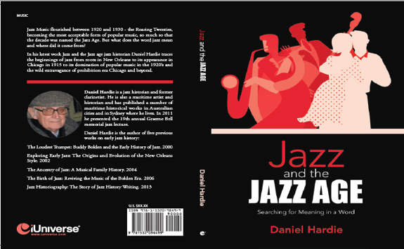

Daniel Hardie’s new work - Jazz and the Jazz Age: Searching for Meaning in a Word, the latest in his series of works on early jazz history, is now available at on-line booksellers.
In this work Daniel Hardie traces the passage of a new form of music from beginnings in New Orleans to Chicago and New York during the heady years of the Roaring Twenties.
A new word entered the language - Jazz - a word that gave a new name to the decade - The Jazz Age. Audiences were dazzled by the new music that rapidly began to dominate popular music in the US and moved on to conquer the world.
It had an appealing sound, bringing with it this strange new and powerful word that seemed to come from nowhere and survived the music of the Jazz Age. What did it mean?
You can get your print copy or eBook of Jazz and the Jazz Age: Searching for Meaning in a Word at:
https://www.iuniverse.com/en/bookstore
or on-line booksellers including: www.Amazon.com.
and https://www.barnesandnoble.com/

Daniel Hardie is the author of five previous works on jazz history:
The Loudest Trumpet: Buddy Bolden and the Early History of Jazz. 2000
Exploring Early Jazz: The Origins and Evolution of the New Orleans Style. 2002
The Ancestry of Jazz: A Musical Family History.2004
The Birth of Jazz: Reviving the Music of the Bolden Era.2006
Jazz Historiography: The Story of Jazz History Writing.2013

Author’s Website: http://tinyurl.com/nqaup

