March
Sunday 3rd | 12.30 pm – 3.30 pm | Village Green Hotel  Mulgrave
Sunday 10th | 12.30 pm – 3.30 pm | Royal Hotel  Upper Ferntree Gully
Sunday 24th | 12.30 pm – 3.30 pm | Blackburn Hotel

April
Sunday 7th | 12.30 pm – 3.30 pm | Village Green Hotel  Mulgrave
Sunday 14th | 12.30 pm – 3.30 pm | Royal Hotel  Upper Ferntree Gully
Sunday 28th | 12.30 pm – 3.30 pm | Blackburn Hotel

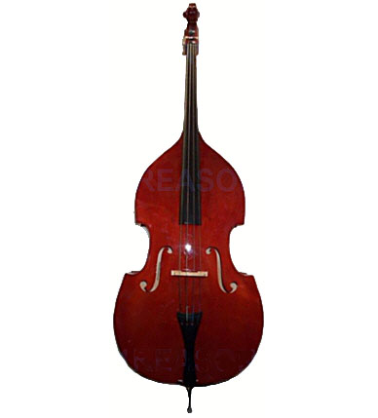
Ross

Venue Address Booking

Blackburn Hotel | 111 Whitehorse Road  Blackburn | Phone 9894 2966
Hotel Bruce County | 445 Blackburn Road  Mount Waverley | Phone 8805 8400
Royal Hotel | 1208 Burwood Highway  Upper Ferntree Gully | Phone 9758 2755
Village Green Hotel | cnr Springvale & Ferntree Gully Roads, Mulgrave | Phone 9560 8400

1 3

