THE NEW MELBOURNE JAZZ BAND
Ross Anderson - Leader
Phone/Fax 61-3-9801 2237
Email: rossandersonjazz@gmail.com
Webpage: www.newmelbournejazzband.com
55 Gateshead Drive
Gig Guide
February, March, April 2019
Wantirna South
Victoria 3152

Gig Guide
February, March, April 2019

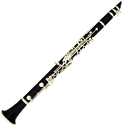
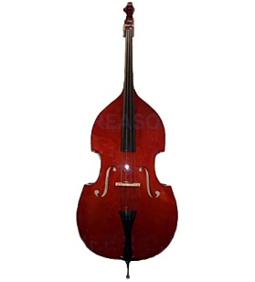
February
Friday 1st | 6.00 pm – 9.00 pm | Hotel Bruce County  Mount Waverley
Sunday 3rd | 12.30 pm – 3.30 pm | Village Royal Hotel  Mulgrave
Sunday 10th | 12.30 pm – 3.30 pm | Royal Hotel  Upper Ferntree Gully
Friday 15th | 6.00 pm – 9.00 pm | Hotel Bruce County  Mount Waverley
Sunday 24th | 12.30 pm – 3.30 pm | Blackburn Hotel

Dinner with the band?

Why not join the quartet on the 1st and 3rd Friday evenings each month when Ross, Charley, Graeme and Mike will entertain you with their swinging Dixieland jazz.
Venue is the Hotel Bruce County, 445 Blackburn Road, Mount Waverley [Pinewood Shopping Village]. The band plays from 6.00 pm to 9.00 pm
in the Heritage Hall.

